ICT



Information and Communication Technology

**Etudiante :** Chabour Cerine

**Groupe :** Chabour Cerine, Laoubi Hadjer, Ayouaz Assia, Ait Hamouda Liniza, Korichi Lina.

**Section :** C

**La date :**Le 03/01/2024

**Professeur:** Dr BOUCHEKIR

**Table of Contents:**

1. Introduction to ICT
   1. Definition and Overview of ICT
   2. Importance and Impact on Modern Society
   3. Evolution of Information and Communication Technologies
2. Google services
   1. Google Search
   2. Gmail
   3. Google Drive
3. Microsoft Tools in ICT
   1. Microsoft Office Suite
   2. Microsoft Teams
   3. OneDrive
4. Git and GitHub
   1. Introduction to version control systems
   2. Git and GitHub
   3. Relevance in Technology
5. Conclusion
6. **Introduction to ICT**
   1. Definition and Overview of ICT:

Technology, Information, and Communication (TIC) represent the intertwined fabric of our modern digital landscape, redefining the way we live, work, and interact. ICT encompasses a triad of pillars, each playing a pivotal role in shaping the global technological ecosystem. Technology involves the hardware and software innovations driving progress, Information encapsulates the data and knowledge that fuels decision-making, and Communication forms the connective tissue facilitating seamless interactions.



* 1. Importance and Impact on Modern Society:

In the 21st century, ICT stands as the cornerstone of societal transformation. Its pervasive influence extends across various domains, revolutionizing how individuals, businesses, and governments operate. The significance of ICT lies not only in its ability to accelerate progress but also in its capacity to democratize access to information, bridge communication gaps, and catalyze innovation. From fostering global connectivity to empowering individuals with unprecedented access to knowledge, ICT has become an indispensable force driving societal evolution.

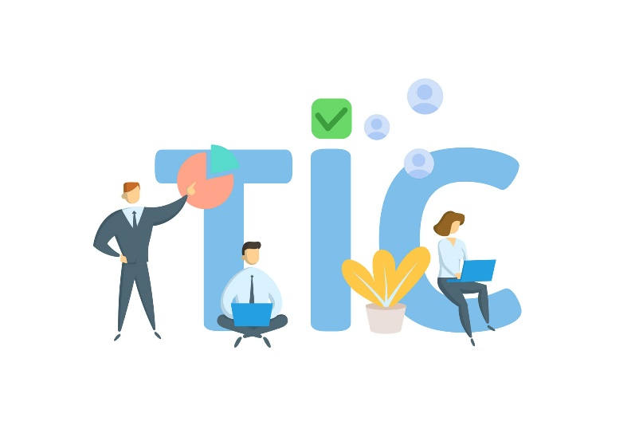

* 1. Evolution of Information and Communication Technologies:

The journey of TIC is a narrative of relentless innovation and evolution. From the rudimentary communication tools of the past to the sophisticated digital ecosystems of today, the trajectory of Information and Communication Technologies (ICT) mirrors human ingenuity. The advent of the internet, mobile technologies, and the digital revolution has transformed the world into a hyper-connected landscape, where information flows seamlessly, transcending geographical boundaries. Understanding the evolution of ICT is paramount to grasping the dynamic forces shaping our present and future.

1. **Google services :**

Google, a technological behemoth, offers a diverse array of services that have become integral parts of our digital lives. These services seamlessly integrate into our daily routines, providing innovative solutions to various aspects of communication, productivity, and information retrieval.

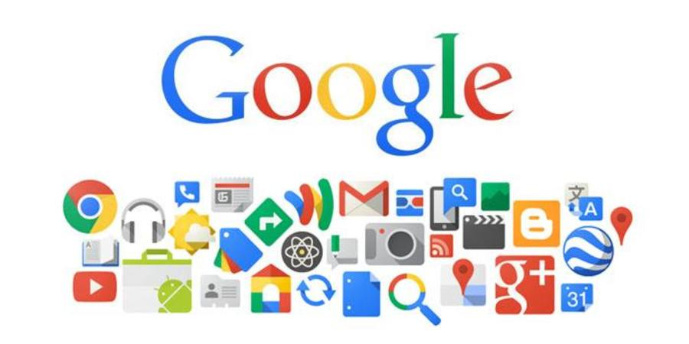

* 1. Google Search:

Google Search stands as the flagship service, revolutionizing the way we access information. With a simple yet powerful interface, Google Search employs sophisticated algorithms to deliver accurate and relevant results in milliseconds. It has transcended being a mere search engine to become a knowledge navigator, answering queries, providing real-time information, and serving as a gateway to the vast expanse of the World Wide Web.

* 1. Gmail:

Gmail, Google's email service, has redefined electronic communication. With a user-friendly interface and robust features, Gmail offers efficient email management, spam filtering, and seamless integration with other Google services. Its cloud-based nature ensures accessibility from anywhere, fostering productivity and collaboration. Gmail has not only streamlined personal communication but has also become a cornerstone for professional correspondence.

* 1. Google Drive:

Google Drive emerges as a paradigm shift in file storage and collaboration. This cloud-based platform allows users to store documents, photos, and videos securely while facilitating seamless sharing and collaboration. The integration of Google Workspace (formerly G Suite) apps within Google Drive, such as Google Docs, Sheets, and Slides, fosters real-time collaboration among users, transcending geographical constraints. The robust version control and synchronization features make it a go-to solution for both personal and professional file management needs.



1. **Microsoft Tools in ICT**

Microsoft Tools stand at the forefront of Technology, Information, and Communication (TIC), providing a robust suite of applications that have become synonymous with productivity and collaboration. These tools seamlessly integrate into the fabric of modern work environments, offering solutions that cater to diverse needs in the realms of information management, communication, and teamwork.

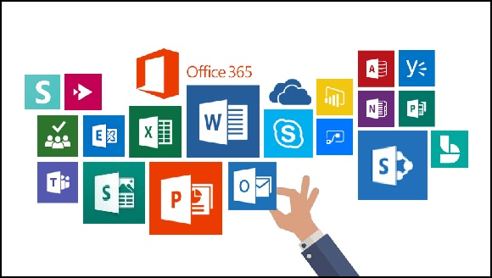

* 1. Microsoft Office Suite :

The Microsoft Suite, commonly known as Microsoft Office, is a set of essential productivity software tools developed by Microsoft. It encompasses applications like Word, Excel, and PowerPoint, designed for document creation, data analysis, and presentations, making it a widely used and versatile solution for various tasks in both professional and personal environments.

|  |  |  |
| --- | --- | --- |
| Microsoft office suite | descreption | Impact /usage |
| Word | it is a user-friendly word processing application, enabling easy document creation and editing with powerful formatting tools. | Microsoft Word simplifies communication tasks, ensuring professional and visually appealing documents. Its impact is evident in streamlined workflows and improved collaboration.Haut du formulaire |
| Excel | is a spreadsheet software that simplifies data management, offering a grid-based platform for calculations, data organization, and visualization through charts. | Excel's impact lies in streamlining tasks across industries, facilitating efficient data analysis, financial modeling, and collaborative work. Its simplicity and versatility make it an essential tool for professionals seeking to manage and analyze data swiftly. |
| Poiwerpoint | It is a presentation software that enables the creation of visually appealing slideshows through a user-friendly interface | PowerPoint simplifies communication by providing a dynamic platform for creating engaging presentations, influencing how information is shared and presented across different contexts. |

* 1. Microsoft Teams:

Microsoft Teams has emerged as a transformative force in the landscape of collaborative communication. Combining chat, video conferencing, file sharing, and application integration, Teams provides a centralized platform for teams to connect and collaborate in real-time. Its versatility makes it an ideal solution for remote work, fostering a seamless flow of communication and collaboration among team members. Teams has redefined how organizations approach virtual meetings, project management, and day-to-day interactions in an increasingly digitalized world.

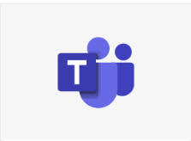

* 1. OneDrive:

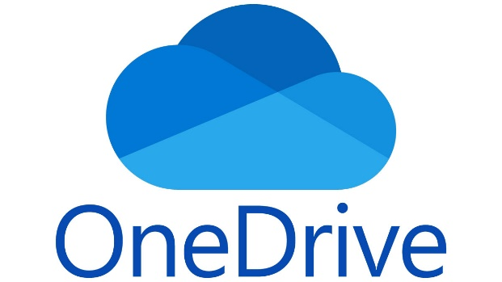

OneDrive, Microsoft's cloud storage solution, serves as a secure and accessible repository for files and documents. It seamlessly integrates with the Microsoft Office Suite and other Microsoft applications, offering users the convenience of storing, syncing, and sharing files across devices. OneDrive's collaborative features enhance productivity by allowing real-time collaboration on documents, ensuring that teams can work together efficiently regardless of their physical location.

1. **Git and GitHub**
   1. Introduction to version control systems :

Version Control Systems (VCS) are foundational tools in software development, enabling teams to track, manage, and coordinate changes to source code over time. These systems maintain a historical record of alterations, providing developers with the ability to collaborate seamlessly, revert to previous states, and merge multiple contributions. By offering a systematic approach to code management, version control systems enhance collaboration, reduce conflicts, and contribute to the overall stability and efficiency of software development projects. They play a critical role in facilitating teamwork, improving code quality, and ensuring the integrity of software throughout its lifecycle.

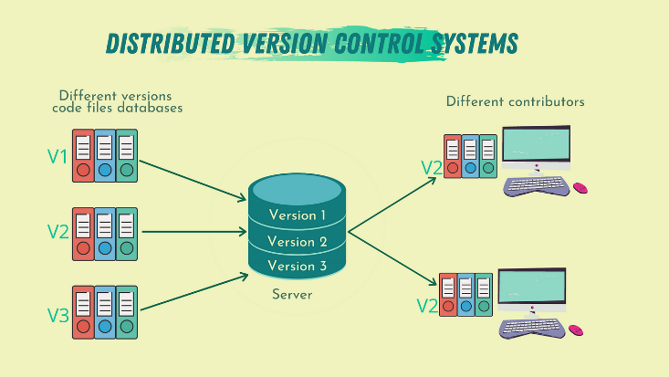

* 1. Git and GitHub

Collaboration lies at the heart of both Git and GitHub, transforming the landscape of software development by fostering efficient teamwork and streamlined workflows. Git, as a distributed version control system, allows developers to work concurrently on different branches, merge changes seamlessly, and maintain a comprehensive history of the codebase. This decentralized approach enables individuals to work independently on local copies of the repository, promoting flexibility and iterative development.

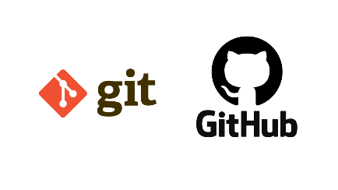

Git and GitHub synergize to create a powerful collaboration ecosystem. Git's decentralized model empowers developers locally, while GitHub's centralized platform enhances collaboration by providing tools and features that streamline communication, code review, and project management. Together, they redefine how development teams collaborate, share, and contribute to projects, whether they are working together in the same room or across the globe.

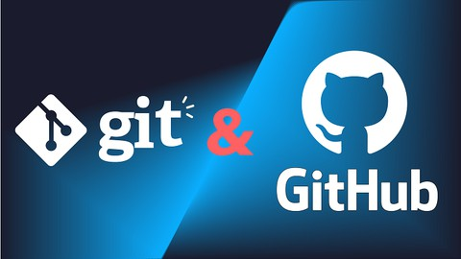

|  |  |  |
| --- | --- | --- |
| feature | Git | GitHub |
| Definition | Distributed version control system | Web-based platform for hosting Git repositories |
| Functionality | Manages source code history locally | Facilitates remote collaboration and code hostiong |
| Centralization | Localized, operates on individual machines | Centralized, hosts repositories on the web |
| Usage | Standalone, can be used independently | Requires an internet connection , collaborative |
| Access Control | Local access control, limited permissions | Robust access control with permissions and roles |
| Usage Cost | Open-source and free to use | Free to public repositories, paid plans for private |
| Examples | Git command-line , Git GUI clients | GitHub desktop , GitKraKen |

* 1. Relevance in Technology:

The relevance of Git and GitHub in technology cannot be overstated. They have revolutionized how developers collaborate, share, and manage code, fostering a culture of openness and transparency in the software development community. The benefits extend beyond version control, influencing practices like continuous integration and deployment. Git and GitHub are integral components of modern development workflows, facilitating the rapid and efficient delivery of software.

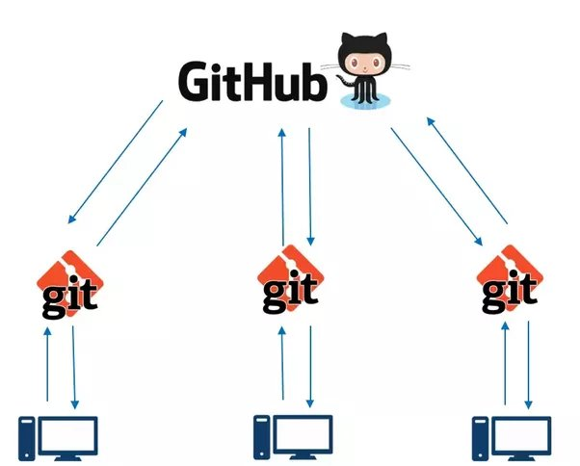

Version control systems, exemplified by Git and GitHub, are essential tools in the realm of technology. They not only streamline collaborative development but also contribute to the overall reliability, maintainability, and scalability of software projects. As technology continues to advance, the role of version control systems remains pivotal in ensuring the agility and success of software development endeavors.

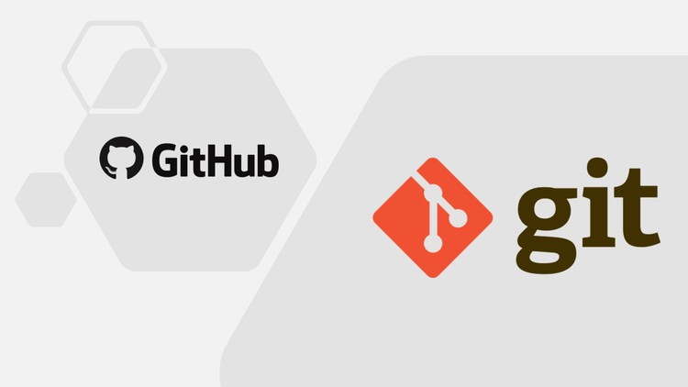

1. **Conclusion :**

In conclusion, our exploration of Technology, Information, and Communication (TIC) reveals its profound impact on the fabric of modern existence. TIC, comprising technologies such as the internet, communication tools, and information systems, has become an inseparable part of our daily lives. It serves as the catalyst for innovation, connectivity, and efficiency in various domains, shaping the way we work, communicate, and access information.



TIC is a dynamic force shaping the present and future of our interconnected world. As we embrace the opportunities and address the challenges presented by TIC, we pave the way for a technologically enriched, collaborative, and inclusive future.